Joseph Silva Jr.

11/20/2021

SNHU

CS 499 – Journal 3-1: Marketing with ePortfolio and Artifact Update

**PART 1:**

* **ePortfolio Evaluation**

There are many benefits with the use of ePortfolio and placing them out sites such as github. A few benefits are being able to keep track of projects by them being organized and time stamped with updates. The organization from the ePortfolio allows me and others (Employers) to easily follow the different Repositories to see when they have been modified and what has been modified. Also, ePortfolio can also be used as a backup system to recover any lost work. The next thing I believe is important is to be able to show the different types of languages I have experience in by setting the language for the Repository to show employers my work with different computer languages such as Python, Java, C++, etc. The last benefit, I am able to show any employer all of work with examples with just giving them my github account hyperlink. I am able to show my work whether I am doing an interview in person or, in today’s era, through a teams’ meeting.

Even though there are benefits with ePortfolio, there are also downsides. The following areas are what I believe are downsides with ePortfolio: corruption of data from outside sources and lack of ePortfolio knowledge. For the first issue, a project can be corrupted by not having the safety measures put in place to prevent access to the main.cpp of a project when it is placed on the internet. Luckily there are safety measures on github which allow the project to be read only and not be manipulated. There are also security designs to allow one a Repository to placed on private.

Next, the lack of ePortfolio knowledge is mostly for businesses and/or employers looking to hire new employees but lack the knowledge or understanding of the ePortfolio design and use. For example, I work for the government in the law enforcement sector for the State. When I brought up the use of my code design and the ePortfolio information, my prior job at a local law enforcement agency had no understanding on how to access or use my ePortfolio to review my work design. In my new job at the State, I had only 3 people be able to understand my explanation of my work and these 3 people were apart of the computer forensic teams. Even though we are miles ahead since I started in government (Law Enforcement), many employers in this sector are still behind on the times when it comes to hiring. I still believe there will be years until new individuals will be appointed with the knowledge to understand ePortfolios and Repositories, but we must adapt to the times until a new era has been established.

**Part 2:**

* **Software design/engineering**

My project uses many files from libraries and files to be brought into the main.cpp file to create the design. For example, the use of shaderfiles were used to develop the 3D design of the objects in the 3D world and without these shaderfiles the program will not run due to an GL error. In order to not lose track of these shaderfiles, I placed a folder into the main project to retrieve these files whenever they are needed, and they can be used by anyone who has the project. Along with the shaderfile folder, I also placed an image folder with my jpg and png files to retrieve the images needed to wrap the texture around the 3D designs.

One thing I changed from my original project; I added all my header files into the include directory of my project. Including these header files, allows the project to automatically retrieve the files without them being manually placed into the project within the sln for my project..

* **Algorithms and data structures**

I added new algorithms and data structures to my project to make the design better. With my design, I added new commands to the camera.h file to allow camera movement to up and down using the Q and E key on my keyboard by using the following commands with the GLFW library:

Main.cpp

Camera.h

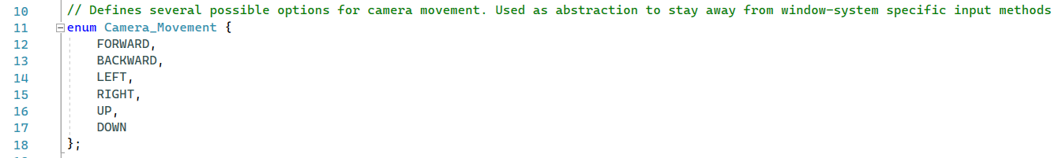

Also, I added data structures such as staticMesh3D.cpp and h files along with vertextBufferObject.cpp and h files to give images in my 3D design better graphics. The following is an example comparing a design from an earlier design of my project with my new one:

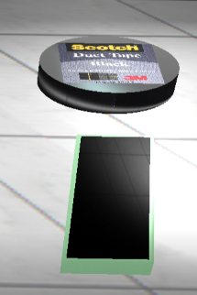 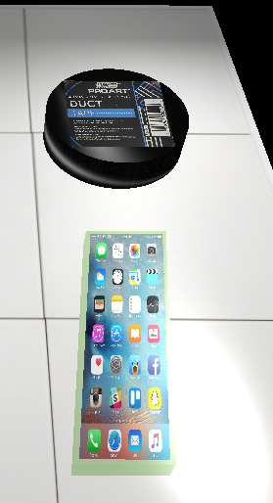

Comparing the designs together, we can see the tile graphics are more realistic and more aligned in the newer version. We can also see the graphics on the duct tape and cellphone are a lot better as well when it comes to the shape and structure of it.

* **Databases**

1.



2.

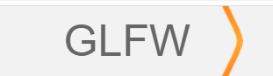

3.

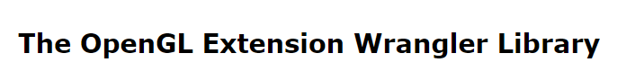

4.

5.

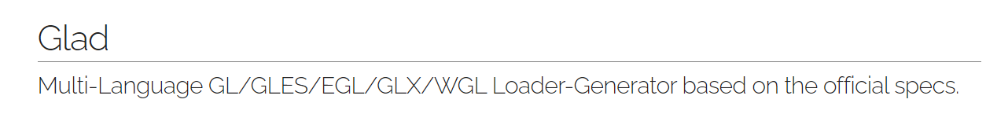

Theses databases have set libraries which allow the use of many dynamic link libraries. These libraries contain many files such as hpp, h, c, and cpp files. These files are then allowed to be used with many programs when developing code. With the use of visual studios 2022 and cMaker, I was able to link these library folders and include folders into my project. In visual studios, these libraries are necessary to allow the creation of .exe programs, the development of a window, and math to create a 3D world. Throughout the first weeks of my capstone, my glew32.lib became corrupt and it was causing havoc to my project by creating errors and failures. Due to these libraries being open sources, I was able to get the newest version of my libraries and link the new libraries to my project. With these new libraries, I was able to add new algorithms and data structures to make my project even better.